“Proclaiming Christ Crucified”

Presbyterian Church in America

Rev. Andrew Gretzinger, Pastor

1901 Evans Avenue
Valparaiso, Indiana 46383
(219) 464-8435
info@goodshepherdpca.net
www.goodshepherdpca.net

Sunday School – 9:20 AM
(No Sunday School in Summer)
Morning Worship – 10:30 AM

By discipling God’s people through the word, prayer, and sacraments, we seek to see the Church redeemed, individual lives transformed, families strengthened, our people equipped for service, our community growing strong in their faith in Jesus Christ, and that Christ would be known among the nations.
ABOUT OUR CHURCH
Good Shepherd Presbyterian Church’s vision is to glorify God in proclaiming the Gospel of Jesus Christ to the church and to the world so that the light of Christ will shine brighter and brighter in our lives, in our family's lives, in the lives of our local community and to the ends of the Earth, all to the glory of God.
TO OUR VISITORS
We are thankful for your visit and warmly welcome you to the worship service today. Please don’t hesitate to stick around after the service to meet us or get more information.
Please scan this QR Code to help us connect with you or fill out the blue form at the welcome desk.
CHILDREN IN WORSHIP
Children of all ages are welcome in worship! The following activities are also available for the children:
Children’s worksheets are available on the windowsill in the back of the sanctuary.
Nursery is available during the worship service for infants.
Church’s Wi-Fi: GSPCA_Valpo-5 glorify1901
Church’s Hashtag: #gspcvalpo
GOOD SHEPHERD PRESBYTERIAN CHURCH
1901 Evans Avenue
Valparaiso, IN 46383
(219) 464-8435
info@goodshepherdpca.net
www.goodshepherdpca.net

December 24th, 2022
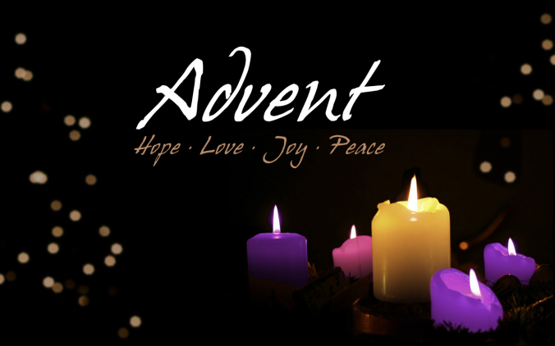

Prelude The Holly & The Ivy

Angles We Have Heard on High Performed by Chris Erickson & Liam Gretzinger

* Please stand if able. Children will sing the first verse and then the congregation will join.
*Opening Carol – What Child Is This No. 213

*Carol – O Come O Come Emmanuel No. 194

Mary Did You Know? Performed by Grayden Lash

*Carol – O Come, All Ye Faithful No. 208

+Women’s choir will sing the first two verses. Please join in on the last two verses.
+The Carol – Let All Mortal Flesh Keep Silence No. 193

Silent Night Performed by Nora Jones

RECOMMENDED CANDLE LIGHTING INSTRUCTIONS
• Hold the candles upright
• Someone will light the first candle in each row
• Tilt your unlit candle slightly towards the lit candle.
• DO NOT TILT the candle that is already lit. This will prevent from spilling hot wax on a person or on the ground

*Concluding Carol – Silent Night No. 210
* Congregation: Please stand as able.
Cast
Chris Erickson Nick Jones
Jed Alderson Nemo Alderson
Ziggy Alderson Lydia Alderson
Kathleen Gretzinger David Gretzinger
Mark Gretzinger Ryan Gretzinger
Aaron Lash Ethan Lash
Grace Martin Isaiah Martin
Adalyn Collins Corinna Collins

Music
Grayden Lash

Join us Tomorrow for our Christmas Day Service
9:30 AM

Liam Gretzinger
Nora Jones

